Online Supplement
Registered replication report: Multilab direct replication of Wegner and Erber (1992) and Wegner et al. (1987)
Wang, Chan, Morys-Carter, Hagger, et al.
This online supplement (OS) consists of two main sections:
- Summary of preregistered plans and actual implementation
  - Study 1: Table 1
  - Study 2: Table 2
- Individual participant data meta-analytic mixed-effects model: Study 2
- Descriptive statistics for self-reported time spent thinking

A: Summary of preregistered plans and actual implementation
Here we demonstrate fidelity to and any deviations from our preregistration by tabulating what was preregistered during the pre-data manuscript stage, and what the actual implementation was for Studies 1 (Table 1) and 2 (Table 2). In summary, for both studies, the overall adherence was high, with analytic flexibility introduced primarily in meta-analytic summarization and supplementary exploratory analyses. All deviations were clearly justified and transparently disclosed.
Table 1
Summary of preregistered and actual implementation for Study 1
Category / Component | Preregistered plan in pre-data manuscript (page number) | Actual implementation in final manuscript (page number)
Design | 2 (Suppression: suppress vs. concentrate) × 4 (Target word: mountain, car, child, house) between-participants design (p. 12) | Adhered (p. 12)
Stimulus modality | Task presented via computerized interface (p. 12) | Adhered (p. 12)
Timeline | Jan to Nov 2023 (p. 9) | Deviated: Jan 2023 to Nov 2024 (p. 11)
Number of labs | 37 (p. 12) | Adhered: 37 (but 1 lab did not record the video and hence had no codable data) (p. 9)
Participants per lab | Minimum of 80 participants per lab post-exclusion (p. 10 and 13); to exclude labs with N < 80 (p. 10) | Deviated: 7 labs failed to meet 80-participant post-exclusion minimum but were included in analysis; their sample sizes were N_{final} = 40, 70, 74, 75, 76, 76, and 78. Supported by editorial decision (p. 12)
Total number of participants | Number not specifically mentioned but strongly implied as total N > 2960 (i.e., 37 × 80) | Adhered: N = 3280 final (p. 16)
Participant inclusion/exclusion criteria | Exclude those who failed suspicion probes or did not comply with instructions (p. 10) | Adhered: We excluded those who failed suspicion probes or compliance checks as preregistered (p. 12)  Not preregistered: We also excluded data lost due to technical issues (e.g., lack of audio) that resulted in uncodable data (p. 12)
Randomization / counterbalancing | Random assignment to suppression vs. concentration  Target word randomization (p. 11); time pressure counterbalanced (p. 12) | Not preregistered (standard practice)  Adhered (p. 13)
Manipulation check | To confirm participants received correct instructions (“I was asked to think/not think…”) | Adhered (p. 16)
Suspicion probe | To assess awareness of study purpose; participants excluded only if they correctly identified the true aim | Adhered (p. 16)
Data recording / coding | Video-record responses; independent coders record prompted responses (p. 18) | Adhered (p. 16, 19)
Interrater reliability | To report as intraclass correlation coefficient (p. 14) | Deviated: Reported as Cohen’s kappa (κ) (p. 19)
Handling of low reliability labs: Coding | To be resolved after discussion between coders (p. 18) | Adhered (p. 19)
Handling of low reliability labs: Analysis | Not preregistered | Retained all data, even those 6 labs with low initial κ (< .75) (p. 19), but exploratory analysis also executed by excluding these labs (p. 26)
Dependent variable | Number of target-word mentions during associate generation task (p. 18) | Adhered (p. 19)
Analysis: ANOVA | To replicate the original Wegner and Erber (1992) analyses using 2 (instructions: suppress vs. concentrate; between-participants) × 4 (target word: mountain, car, child, house; between-participants) × 2 (word type: target vs. non-target; within-participants) × 2 (time pressure: 3s vs. 10s; within-participants) ANOVA, that would eventually reduced to 2 (instructions: suppress vs. concentrate; between-participants) × 2 (time pressure: 3s vs. 10s; within-participants) ANOVA, regardless of the results of the 2 × 4 × 2 × 2 ANOVA (p. 18-19) | Adhered: Conducted ANOVA per lab (p. 19-20)
Prediction: ANOVA | Nonsignificant 4-way interaction; nonsignificant condition × target word interaction; nonsignificant time pressure × target word interaction (p. 18) | Adhered (p. 20)
Interpretation: ANOVA | Not specified | Not preregistered: how to summarize ANOVA results from all labs; used meta-analysis of ηp² (not preregistered metric); interpreted descriptively (p. 20)  Transparent reporting: Emphasized interpretive caution; noted small and bounded ηp² values (p. 20)
Mixed-effects model analysis | Planned model with random intercepts for participant and target word; remove target word if convergence failed (preregistered fallback) (p. 19) | Adhered: dropped target word random effect due to convergence issues (p. 22)  Not preregistered: restricted the analyses on target words only (p. 22)
Mixed-effects nonconvergence (fallback) | If no models converge despite model simplification, then conclude mixed models are inappropriate (p. 19) | Not mentioned because simplified model converged
Interpretation: Mixed-effects model | Not preregistered in pre-data manuscript but documented in email correspondence with Editor | Omission from preregistration acknowledged: mixed-effects model (condition × time pressure × word type) (p. 22)
Individual participant data (IPD) meta-analytic mixed model | Condition × time pressure IPD meta-analytic mixed model not preregistered | Reported in footnote 11 (p. 24)
Immediate enhancement effect computation | Compute d_{low} and d_{high} (low vs. high time pressure); evidence for immediate enhancement effect: d_{low} < 0 and d_{high} > 0 (p. 19) | Adhered (p. 23-24)
Preregistered analyses: exploratory comparisons | Manipulation check, gender, region, less-than-excellent ICCs (< .75); no specified directionality (p. 21-22) | Adhered (p. 26)
Data sharing | Analysis code and data to be available on OSF (p. 8) | Adhered: Code and materials shared via OSF link (https://osf.io/u3nza/) (p. 9)
Table 2
Summary of preregistered and actual implementation for Study 2
Category / Component | Preregistered plan in pre-data manuscript (page number) | Actual implementation in final manuscript (page number)¹
Design | 2 (instructions: suppression vs. concentration) × 4 (target thoughts: tiger, gorilla, food, diseases) between-participants (p. 22) | Adhered (p. 26)
Stimulus modality | Task presented via computerized interface (pp. 22-24) | Adhered (p. 27)
Timeline | Jan to Nov 2023 (p. 9) | Deviated: Jan 2023 to Nov 2024 (p. 11)
Number of labs | Not stated, but implied as 37, derived from the fact that Studies’ 1 and 2 recruitment is linked (p. 26) | Adhered: 37 (but 1 lab couldn’t complete data collection) (p. 26, 31)
Participants per lab | Minimum of 80 participants per lab post-exclusion (p. 24); to exclude labs N < 50 (p. 22). We acknowledge that two different sample sizes (50 and 80) were mistakenly preregistered in different pages of our preregistered plan. We should only have preregistered N = 80. | Deviated. If N = 80 is the criteria, 9 labs fell below that criteria, with sample sizes N_{final} = 41, 47, 62, 72, 74, 78, 78, 79, and 79. Like in Study 1, we retained all labs’ data because they were good-faith attempts.
Total number of participants | Number not specifically mentioned but strongly implied as total N > 2960 (i.e., 37 × 80) | Adhered: N = 3053 final (p. 31)
Participant inclusion/exclusion criteria | Exclude those who failed suspicion probes or did not comply with instructions (p. 22) | Adhered (p. 26)  Not preregistered: We also excluded data lost due to technical issues (e.g., static noises) that resulted in uncodable data (p. 31). One lab contributed only Period 2 data; Period 1 data were missing. Period 2 was included, and the missing Period 1 data are disclosed in the online supplement (see OS: Table B2).
Randomization / counterbalancing | Random assignment to suppression vs. concentration; target word randomization (p. 25) | Adhered (p. 27)
Manipulation check | To confirm participants received correct instructions (“I was asked to think/not think…”) (p. 24) | Adhered (p. 30)
Suspicion probe | Included to assess awareness of study purpose; participants excluded only if they correctly identified the true aim (p. 25) | Adhered (p. 30)
Data recording / coding | Video-record responses (p. 22); independent coders record responses (p. 29) | Adhered (p. 27, p. 30)
Handling of low reliability labs: Coding | To be resolved after discussion between coders (p. 29) | Adhered (p. 31, 36)
Main dependent variables | Target thought frequency (mentions, bell rings, combined total) (p. 29) | Adhered (p. 36, 37)
Complementary dependent variable | Preregistered (p. 31) | Adhered (p. 30)
Analysis: ANOVA | 2 (initial instructions: suppression vs. concentration) × 4 (target thought: gorilla vs. tiger vs. food vs. diseases) ANOVA, collapsed across target thought regardless of the interaction | Adhered (p. 36)
Mixed-effects model | Target word as random intercept; convergence failure warrant model simplification (p. 30)  Not preregistered: how to deal with convergence warning | Deviated: Target word as both random and fixed effect (p. 36)  Deviation: The models did converge, but because the convergence warnings were deemed concerning enough, the model was also simplified by removing target word as random effect (p. 36)
Mixed-effects nonconvergence (fallback) | If no models converge despite model simplification, then conclude mixed models are inappropriate (p. 30) | Not needed because simplified model converged
Main rebound effect comparison | Preregistered: Concentration cell from the initial suppression condition of period 2 compared with concentration cell from the initial concentration condition of period 2 (p. 25) | Adhered (p. 29, 37)
Alternative rebound effect comparison | Preregistered: Wegner et al. (1987): Concentration cell from the initial suppression condition of period 2 compared with concentration cell from the initial concentration condition of period 1 (p. 29) | Adhered (p. 38)
Analysis: Meta-analysis | Compute rebound effect (Cohen’s d) across labs (p. 29) | Adhered (p. 37)
Outliers | Not preregistered: how to deal with outliers in a meta-analysis | Outliers identified by metafor::influence(). For all analyses, we presented results with and without outliers removed.
Analysis: Target word-specific | Preregistered, with directionality mentioned, i.e., tiger & gorilla > food & diseases (p. 31) | Adhered (p. 37-38)
Individual participant data (IPD) meta-analytic mixed model | Not preregistered
Preregistered analyses: exploratory comparisons | Manipulation check, gender, region, less-than-excellent ICC (< .75); no specified directionality (p. 31) | Adhered (p. 40)
Exploratory analysis: Correlation of effect sizes | Not preregistered: Correlation of effect sizes between primary and secondary comparisons | Reported in Tables 6 and 7 (main manuscript) and B1 (online supplement)
Data sharing | Analysis code and data to be available on OSF (p. 8) | Adhered: Code and materials shared via OSF link (https://osf.io/u3nza/) (p. 9)

B: Individual participant data (IPD) meta-analytic mixed-effects model: Study 2
A meta-analysis of aggregated condition means, as reported in the main manuscript, has the advantage of producing intuitive effect size estimates in a familiar metric (Cohen’s d). However, when raw data is available, IPD meta-analysis offers more precise estimates of an effect, though in a less familiar metric (regression beta). The following IPD meta-analyses (not preregistered) complement the meta-analysis of aggregated data reported in the main manuscript.
Period 2 Concentration (Initial Concentration) vs Period 2 Concentration (Initial Suppression)
A series of mixed effects models examined the rebound effect in Period 2. The first model predicted target-prompted thoughts from condition (initial suppression = 1 vs. initial concentration = 2) and word type (tiger, gorilla, food, disease), with a random intercept for Lab. Participants who initially suppressed target thoughts had target-prompted responses than those who initially concentrated on target thoughts, b = −3.37, p = .005, providing evidence for the rebound effect. Because word type has four levels, it is easier to interpret using just one Type III ANOVA instead of three dummy-coded effects. Type III ANOVA revealed a nonsignificant condition × word type interaction, F(3, 2992) = 1.20, p = .31, indicating the effect of condition was largely consistent across words. Despite the nonsignificant interaction, performing simple effects is still warranted because it directly examines whether the rebound effect exists within tiger and gorilla but not food and diseases, as we preregistered. Planned pairwise comparisons revealed that the rebound effect was significant for tiger (estimate = 3.37, p = .0048) and gorilla (estimate = 3.33, p = .0053), but nonsignificant for food (estimate = 0.87, p = .47) or disease (estimate = 1.34, p = .26). Even after removing the two outlier labs (same as the main manuscript), the overall rebound effect became more evident, b = −3.79, p = .002; the condition × word type interaction remained nonsignificant, F(3, 2802) = .94, p = .420.
Period 2 Concentration (Initial Suppression) vs Period 1 Concentration (Initial Concentration)
A second model compared the concentration condition from the initial suppression in Period 2 with the concentration condition from the initial concentration in Period 1. Target-prompted responses were greater in Period 2 following initial suppression than in Period 1 following initial concentration, b = −2.50, p = .033, again demonstrating evidence for the rebound effect. The condition × replication interaction approached significance, F(3, 2970) = 2.43, p = .063. Pairwise comparisons showed significant effects for tiger (estimate = 2.50, p = .033) and gorilla (estimate = 2.96, p = .011). No significant differences were observed for food (estimate = 0.22, p = .85) or disease (estimate = −0.86, p = .46). Even after removing the outlier lab (same as the main manuscript), the overall rebound effect remained significant, b = −2.37, p = .045, as well as for tiger (p = .045) and gorilla (p = .012), but not for food (p = .614) or disease (p = .463); the condition × replication interaction remained marginal, F(3, 2919) = 2.18, p = .088.
Self-reported percentage of time spent thinking about the target
Using percentage of time spent thinking about the target as an alternative measure, participants who initially suppressed reported that they spent more time thinking than those who initially concentrated, b = −8.72, p < .001.
Summary
Together, these analyses converge to show a reliable rebound effect across different comparison conditions (ours vs Wegner et al.’s), dependent variables (target-prompted responses vs percentage time spent thinking), meta-analytic methods (aggregate data vs. mixed effects IPD).
C: Descriptive statistics for self-reported time spent thinking
In the manuscript, we reported “[t]he meta-analytic effect size was larger than using target thought occurrence as the dependent variable, d = 0.31 [0.15, 0.47], p < .001, indicating that during the final concentration period, those in the initial suppression condition spent more time thinking about the target thoughts than those in the initial concentration condition”. Below we present the means and standard deviations (Table C1), as well as the forest plot (Figure C1), supporting this analysis.
Table C1
Mean (SD) percentage self-reported percentage time spent thinking about target thought
No. | Author(s) | Initial concentration | Initial suppression
1 | Agustina & Liem | 67.00 (22.79) | 73.83 (21.41)
2 | Astle et al. | 60.96 (21.36) | 65.76 (26.73)
3 | Baldwin | 57.59 (27.08) | 63.40 (24.74)
4 | Brady et al. | 63.71 (26.61) | 66.46 (27.67)
5 | Calvillo et al. | 50.84 (31.10) | 60.59 (31.94)
6 | Gregori-Labarta & Dobkins | 61.33 (25.40) | 71.90 (25.02)
7 | Hagger et al. | 30.46 (23.47) | 59.14 (31.47)
8 | Hartanto et al. | 71.97 (22.25) | 29.27 (24.61)
9 | Hawk | 55.21 (28.71) | 68.40 (23.85)
10 | Hirt et al. | 53.11 (29.97) | 71.22 (21.95)
11 | Hussey et al. | 57.62 (25.79) | 68.60 (18.49)
12 | Hüffmeier et al. | 57.19 (23.85) | 64.58 (26.88)
13 | Isloi et al. | 61.22 (26.96) | 64.06 (22.38)
14 | Jia et al. | 66.87 (23.82) | 69.90 (26.92)
15 | Kim et al. | 55.58 (28.72) | 68.54 (25.93)
16 | Kroker et al. | 58.06 (24.27) | 66.43 (23.52)
17 | Ku | 55.89 (23.80) | 62.67 (25.39)
18 | Kumalasari & Novita | 62.90 (22.11) | 71.98 (23.44)
19 | Levy & Ngyuen | 54.11 (24.97) | 60.73 (35.08)
20 | Lin et al. | 57.06 (20.33) | 64.59 (23.38)
21 | Linden & Vail | 51.31 (26.46) | 61.97 (28.05)
22 | Lopez et al. | 52.98 (30.70) | 73.67 (21.81)
23 | Ma-Kellams & Lim | 38.08 (29.66) | 61.61 (27.73)
24 | Mammarella et al. | 62.29 (26.16) | 60.53 (23.87)
25 | Moskowitz | 57.11 (28.60) | 65.25 (27.01)
26 | Prada et al. | 72.20 (22.36) | 70.92 (23.24)
27 | Saraiva et al. | 67.00 (23.93) | 70.20 (24.15)
28 | Schütz et al. | 60.42 (22.11) | 73.03 (21.27)
29 | Toh et al. | 59.98 (29.03) | 70.22 (20.94)
30 | Wang et al. | 44.74 (26.51) | 59.72 (30.19)
31 | Wilkowski et al. | 64.31 (23.02) | 71.32 (23.61)
32 | Wong et al. | 44.03 (28.88) | 66.31 (25.99)
33 | Xu et al. | 57.93 (26.76) | 58.50 (28.11)
34 | Yusainy et al. | 54.83 (27.37) | 56.15 (30.28)
35 | Zerhouni et al. | 32.14 (21.92) | 66.56 (23.39)
36 | Zhang et al. | 69.93 (25.89) | 61.88 (30.21)
Figure C1
Forest plot of self-reported percentage time spent thinking within Period 2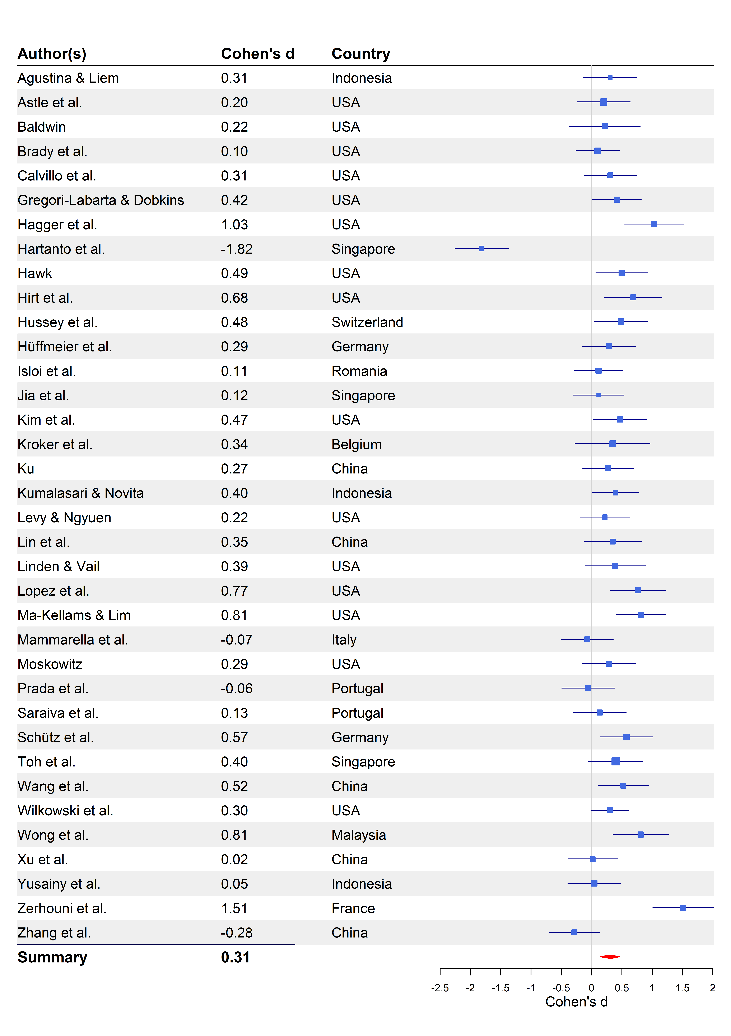
One of the labs was identified as an outlier (see Figure C1). When this lab’s data was removed, the effect was stronger, d = 0.36 [0.25, 0.47], p < .001.
Figure C1
Outlier metrics of plotted against lab number
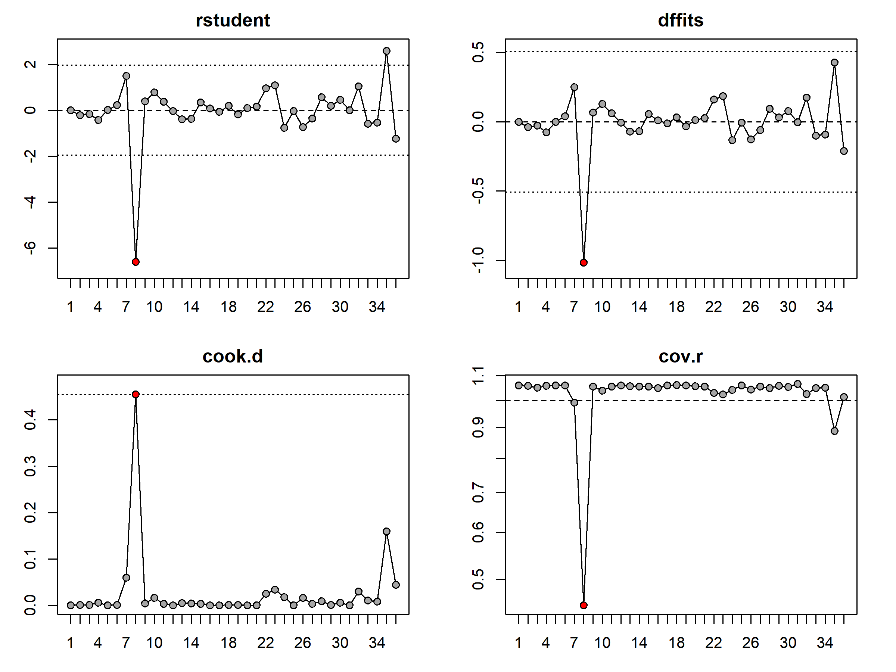
Note. Red dot indicates outlier. Plot shows Studentized residuals (rstudent), Cook’s distances (cook.d), change in predicted values if study is removed (dffits), covariance ratio (cov.r).

Page numbers will be different in the final publisher-formatted version.

